Georgia State Parks and Historic Sites
Weekend Summary
06.15.2020

Crowds:

- Sites that had to temporarily limit day use access due to capacity include: beach at Don Carter, beach at Mistletoe, beach at Richard B. Russell, beach at Tugaloo, Cloudland Canyon, Ft. Yargo, Red Top, Sweetwater, Tallulah Gorge, Tugaloo, and Vogel. Sweetwater Creek, Red Top Mountain, and Fort Yargo are not limiting access as many times per day as they were in previous weekends.

- Golf Course activity was very busy again this week, up 115% over last year. Laura Walker had to limit to cart path only due to heavy rains soaking the course. The Creek at Hard Labor ran out of golf carts on Sunday due to high use.

Staffing issues:
- As of today, the Division has 46 part-time and full-time staff out due to COVID-19 related reasons. A total of 42 Camp Host Units (approximately 84 people) have left due to COVID-19 and 39 units have been replaced.
- Skidaway’s Utility Worker is being recalled to active duty in the Naval Reserve until September 2021.

Positives
- Museums and Historic sites opened successfully. Capacity limits worked well to manage access while some adjustments were made throughout the day to better route visitors. Visitors were understanding of the restrictions of the number of people. Due to high visitation Wormsloe and Fort King George placed staff members at the entrance doors to control the numbers of visitors in the building at any one time.

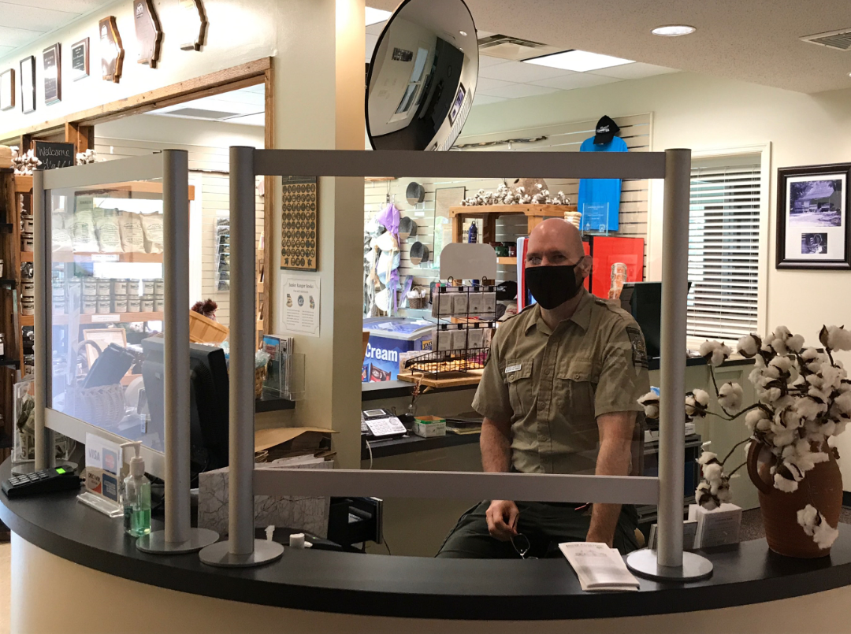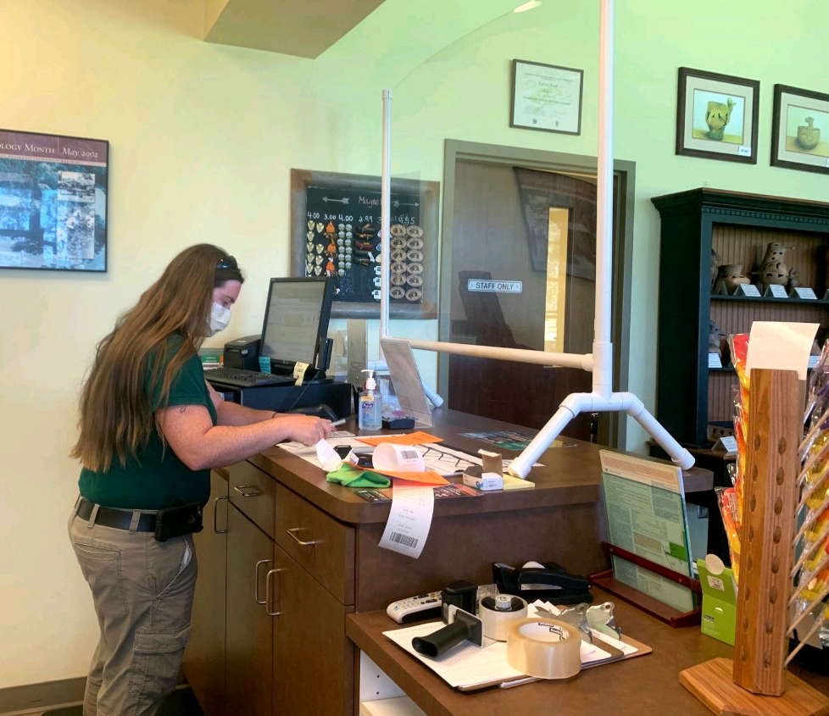
Jarrell Plantation Kolomoki Mounds

- Following the CDC guidelines, sites re-opened playgrounds throughout the state.

- The Marketing unit continues to have someone on call each weekend to post access restrictions on the website and monitor social media which has been a big benefit to our Park Visitors. As in-person programs increase, the eRanger video series is coming to an end. This outreach effort was overwhelming successful and in 11 weeks had a Facebook reach of 1,309,700, web pageviews of 7,897 and YouTube views of 6,100. Website statistics continue to soar. Total pageviews were up 93% this past week, and year to date there has been over 26 million. This past week Reservations pageviews were up 62% and Alerts Page pageviews was 18,145.

- RMU completed the George L Smith fish attractor project, a collaboration with Park Staff, Fisheries Management and RMU. Staff constructed 55 fish attractors (made of PVC piping, tubes, cement, and a plastic bucket), installed fish feeders onto 3 floating docks, built twelve 125 lb concrete anchors with chains for the docks, and then distributed the docks and attractors.

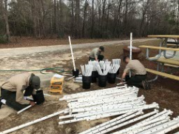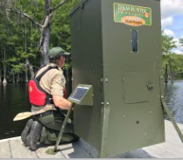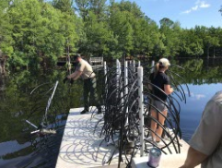

Challenges
- The number of cottage turnovers and staff shortages at several sites continues to be a challenge. Park Managers and Assistant Managers are spending considerable time cleaning cottages, but it prevents them from covering the site, sometimes at peak times. Managers are working hard to rehire part time positions as fast as they can. Many sites are also experiencing a high volume of phone calls, with some sites answering several hundred phone calls per day.
- The opening of picnic shelters and group shelters has created new challenges for sites that reach capacity, having to ensure parking is left open for rented shelters.
- LED issued several citations at Tallulah Gorge for people not having permits to hike the gorge floor.
- Elijah Clark State Park requested DNR LED assistance on Saturday afternoon to disperse a crowd of 85 people gathered on the beach for a party.
- LED was called to a disturbance on the beach at Laura Walker. All parties were instructed to leave.
- Arrowhead Pointe had a law enforcement issue with a player that is under investigation.
- SC Foster is working through issues dealing with the cleaning requirements to re-renting boats on the same day.
- Wormsloe found that it was not practical to be able to show the site film in the theater on the weekend and stick to the occupancy limit on the museum. Guests are given the web address to view on-line.
- Kolomoki staff dealt with a male subject threatening suicide. Early County SO assisted and took him into custody.
- On Sunday, Reed Bingham staff found a stolen vehicle parked in a wooded area near their burn pile. Cook County SO reported being involved in a chase with this vehicle on Saturday.

Financial Update
Past Weekend:
Our overall occupancy for all reservables increased 2% this past weekend to 75%. Camping increased 4%, reaching 85% occupancy. And yurts were at 99% occupancy, the same as the previous year. Cottage rentals dropped this past weekend by 4% to 82% occupied.
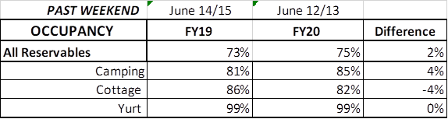
Upcoming Weekend:
For the upcoming weekend, we are already seeing a 7% increase in all reservables at 75% occupancy. Camping and yurts are both showing a 10% increase to 86% and 97%, respectively. But cottages are showing a 1% decrease down to 85% occupancy.
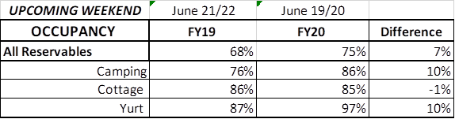
Revenue:
YTD thru June 14th, our park receipts have increased 7% or $2.1 Million. This past week, June 7th -14th, there was a 53% or $413,000 increase in overall revenue. This is the 9th week in a row revenue has increased since COVID began.
For overnight accommodations – camping revenue continues to significantly increase. This past week camping improved 83% or $195,000. Cottages also saw a significant increase this past week and doubled revenue from the previous year, increasing $217,000 to $433,000, yurts improved 74% or $11,000.
Golf was up 115% this past week or $28,000.
Online Park Pass Sales - This past week, ParkPass revenue almost doubled, increasing 98% or $73,000 compared to last year. Launching the new QR code and the online daily ParkPass option, sales have been very successful:
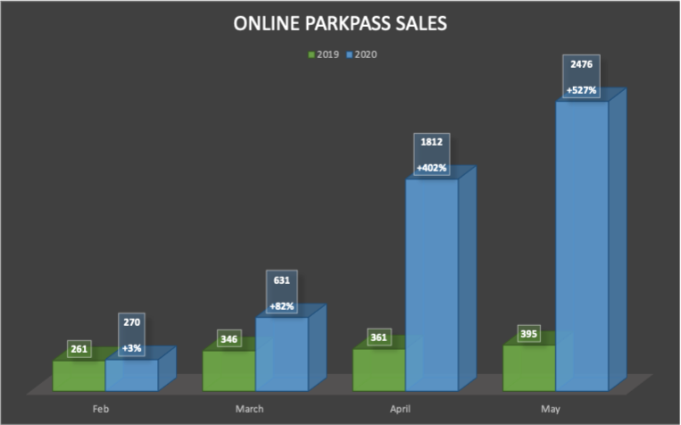
The revenue continues to significantly improve over last week due to several reasons:
- In early April we changed policy from collecting only a one-night deposit when booking a reservation, to collecting all revenue at the time of booking. This is the reason for the significant increase to camping, cottage and yurt revenue. This will have an effect on future revenue collections and the amount of refunds given.
- Camping occupancy has actually improved over the previous year for the 9th weekend in a row. And cottage and yurt occupancy is improving as well.
- And again, the number of cancellations is starting to significantly slow down. Although we do need to keep in mind, that for future refunds, we will be refunding the revenue for the entire stay, rather than just a one-night deposit.

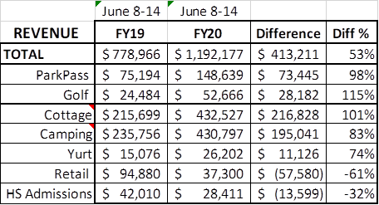
Cancellations/Refunds:
Through June 15th, there have been 32,000 reservation cancellations, including $2.8 Million in actual refunds and a loss of future revenue of $12 Million. This is 1,000 more than last Monday, when we were at 31,000 cancellations. The significant drop in the number of cancellations continues, as initially we had 4,000 – 5,000 a week, although we do continue to see a higher number of cancellations than the previous year. Last year during the same week we had 725 cancellations, thus we had 275 more cancellations this past week than last year during the same time period.
Last year during March thru YTD, we had 12,110 cancellations, including $620,000 in actual refunds and a loss of future revenue of $2.9 Million. So, total cancellations have increased over 18,890 or 156% and the amount of refunds have increased $2.2 Million.

